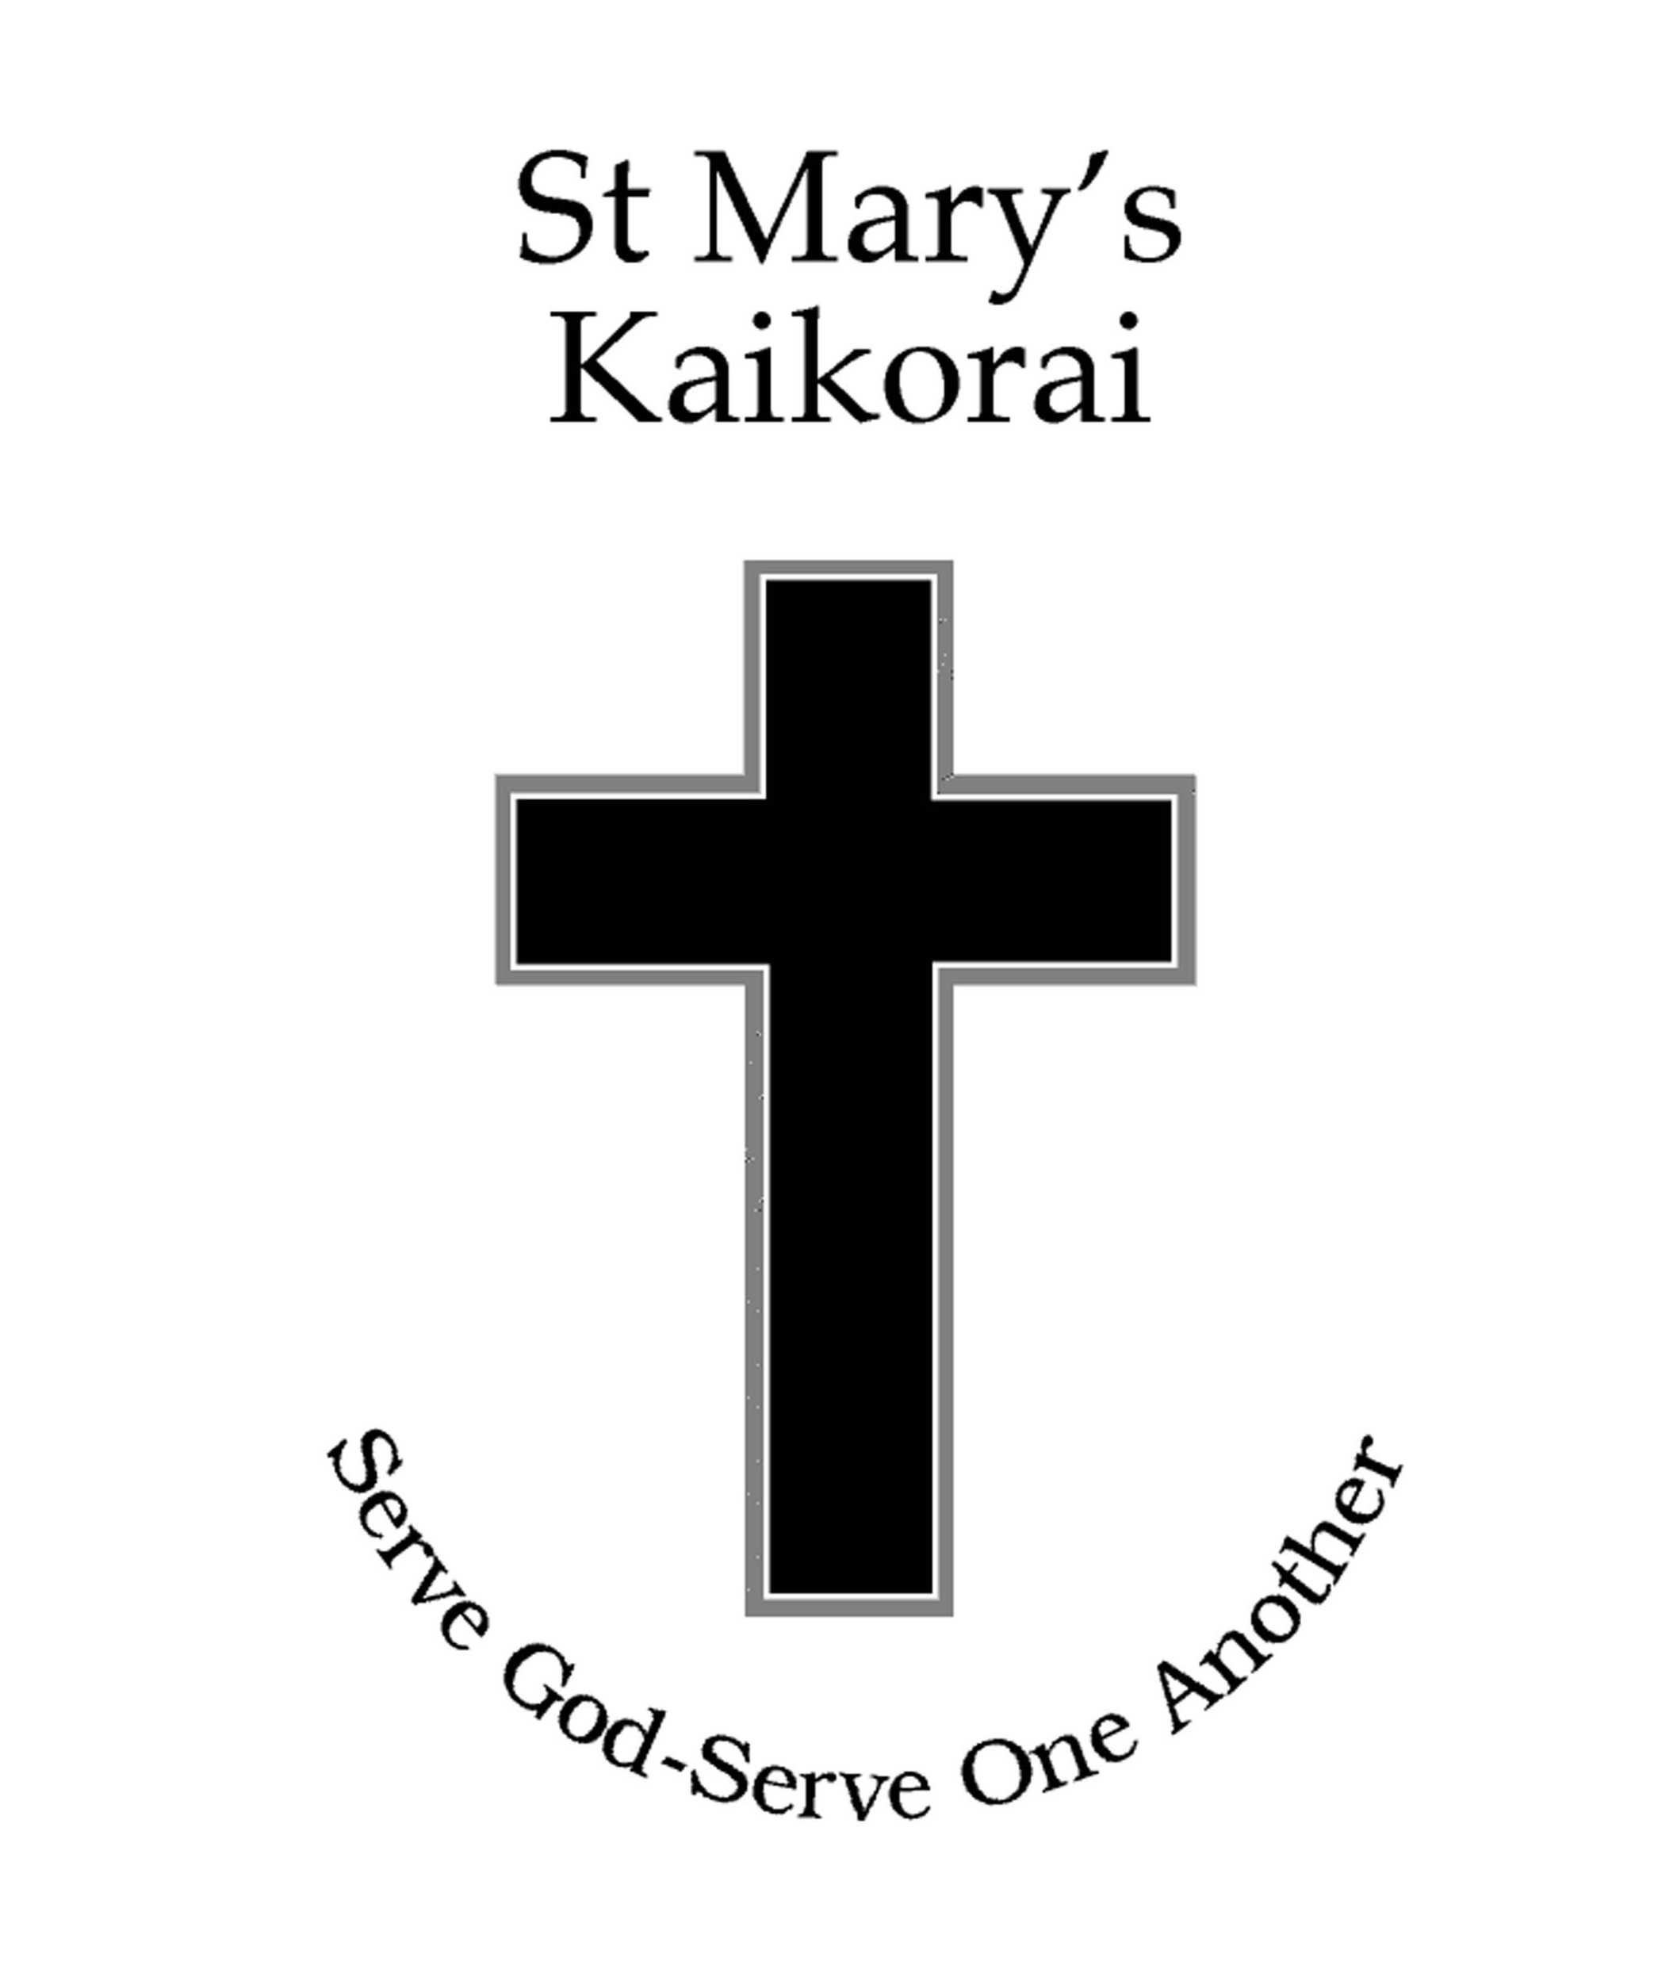St Mary’s School, Kaikorai
National Administrative Guidelines
2012

NAG 1
Each board of trustees is required to foster student achievement by providing teaching and learning programmes which incorporate The National Curriculum as expressed in The New Zealand Curriculum 2007 or TeMarautanga o Aotearoa.
Each board, through the principal and staff, is required to:
(a) develop and implement teaching and learning programmes:
- to provide all students in years 1-10 with opportunities to achieve for success in all areas of the National Curriculum;
- giving priority to student achievement in literacy and numeracy, especially in years 1-8;
- giving priority to regular quality physical activity that develops movement skills for all students, especially in years 1-6.
(b) through a range of assessment practices, gather information that is sufficiently comprehensive to enable the progress and achievement of students to be evaluated; giving priority first to:
- student achievement in literacy and numeracy, especially in years 1-8; and then to
- breadth and depth of learning related to the needs, abilities and interests of students, the nature of the school's curriculum, and the scope of The National Curriculum as expressed in The New Zealand Curriculum or TeMarautanga o Aotearoa;
(c) on the basis of good quality assessment information, identify students and groups of students:
- who are not achieving;
- who are at risk of not achieving;
- who have special needs (including gifted and talented students); and
- aspects of the curriculum which require particular attention;
(d) develop and implement teaching and learning strategies to address the needs of students and aspects of the curriculum identified in (c) above;
(e) in consultation with the school's Māori community, develop and make known to the school's community policies, plans and targets for improving the achievement of Māori students; and
(f) provide appropriate career education and guidance for all students in year 7 and above, with a particular emphasis on specific career guidance for those students who have been identified by the school as being at risk of leaving school unprepared for the transition to the workplace or further education/training.
NAG 2
Each board of trustees, with the principal and teaching staff, is required to:
(a) develop a strategic plan which documents how they are giving effect to the National Education Guidelines through their policies, plans and programmes, including those for curriculum, National Standards, assessment and staff professional development;
(b) maintain an on-going programme of self-review in relation to the above policies, plans and programmes, including evaluation of information on student achievement; and
(c) report to students and their parents on the achievement of individual students, and to the school's community on the achievement of students as a whole and of groups (identified through NAG 1(c) above) including the achievement of Māori students against the plans and targets referred to in 1(e) above.

NAG 2A
Where a school has students enrolled in years 1-8, the board of trustees, with the principal and teaching staff, is required to use National Standards to:
(a) report to students and their parents on the student’s progress and achievement in relation to National Standards. Reporting to parents in plain language in writing must be at least twice a year;
(b) report school-level data in the board’s annual report on National Standards under three headings:
- school strengths and identified areas for improvement;
- the basis for identifying areas for improvement; and
- planned actions for lifting achievement.
(c) report in the board’s annual report on:
- the numbers and proportions of students at, above, below or well below the standards, including by Māori, Pasifika and by gender (where this does not breach an individual’s privacy); and
- how students are progressing against the standards as well as how they are achieving.
These requirements do not apply to boards of trustees that are working towards implementing TeMarautanga o Aotearoa until 2 February 2011.
For the avoidance of doubt, the first annual report to which subclauses (b) and (c) apply is that which reports on the 2011 school year, except for boards of trustees that are working towards implementing TeMarautanga o Aotearoa when the relevant report is that which reports on the 2012 school year.

NAG 3
According to the legislation on employment and personnel matters, each board of trustees is required in particular to:
(a) develop and implement personnel and industrial policies, within policy and procedural frameworks set by the Government from time to time, which promote high levels of staff performance, use educational resources effectively and recognise the needs of students; and
(b) be a good employer as defined in the State Sector Act 1988 and comply with the conditions contained in employment contracts applying to teaching and non-teaching staff.

NAG 4
According to legislation on financial and property matters, each board of trustees is also required in particular to:
(a) allocate funds to reflect the school's priorities as stated in the charter;
(b) monitor and control school expenditure, and ensure that annual accounts are prepared and audited as required by the Public Finance Act 1989 and the Education Act 1989; and
(c) comply with the negotiated conditions of any current asset management agreement, and implement a maintenance programme to ensure that the school's buildings and facilities provide a safe, healthy learning environment for students.

NAG 5
Each board of trustees is also required to:
(a) provide a safe physical and emotional environment for students;
(b) promote healthy food and nutrition for all students; and
(c) comply in full with any legislation currently in force or that may be developed to ensure the safety of students and employees.

NAG 6
Each board of trustees is also expected to comply with all general legislation concerning requirements such as attendance, the length of the school day, and the length of the school year.

