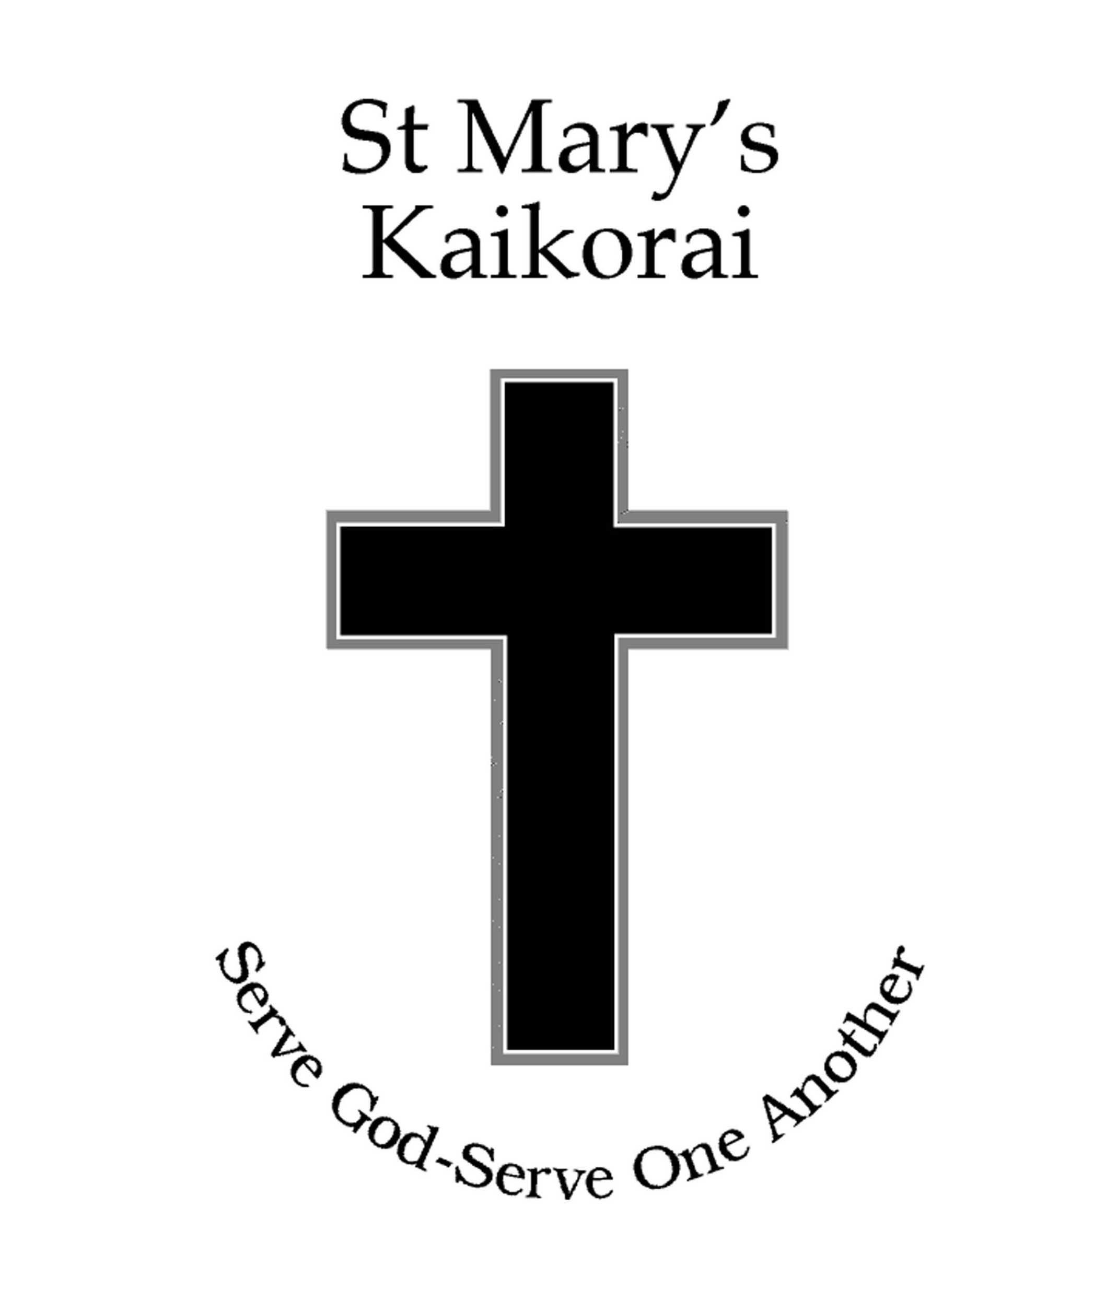
St Mary’s Kaikorai School

Property Management Policy
Rationale:
St Mary’s Kaikorai School Board of Trustees will endeavor to provide a safe and well resourced environment in which children can excel and staff can thrive. The Board, guided by the Health and Safety Policy, will maintain the grounds, buildings and facilities in clean and hygienic condition.

Guidelines
This is achieved by:
- Compiling and maintaining a register of fixed assets with a reasonable system for recording depreciation.
- Maintaining, replacing and renewing fixed assets, after proper consultation with staff and Principal.
- Developing and maintaining a 10 year property maintenance program that forecasts both minor and major projects in order to prioritise expenditure. This document is used to keep the Proprietor appraised of capital works and costings.
- Maintaining a faults register where damage to fencing, building, grounds and fixed assets is recorded and remedial action is detailed.
- Arranging and monitoring property related work and providing reports to the Board as required.
- Establishing a monthly report of buildings and grounds to the Principal and Board to comply with the occupancy agreement
- Delegating parts of the program to a sub-committee, or consultant from time to time and who would report to the Board at the meetings, where appropriate.
- Delegating the day to day administration of this policy as the responsibility of the Principal.
- Establishing a property sub-committee or property officer who will liaise with the Principal on the management of the property program.
- Monitoring regularly and reviewing this policy every three years.

Signed __________________ Date: September 2011 Review Date: September 2014

